Maer Village Newsletter

Village website – www.maervillage.co.uk

Village Hall Registered Charity Number: **503432**

June 2019

**EVENTS/INFO**

**Neighbours day -19th May**

Maer Community Group organised this event to bring together old, current and new neighbours of Maer village. This was a really successful event with over 40 people attending. Fabulous cakes and beautiful floral displays from Sandy (our resident florist)

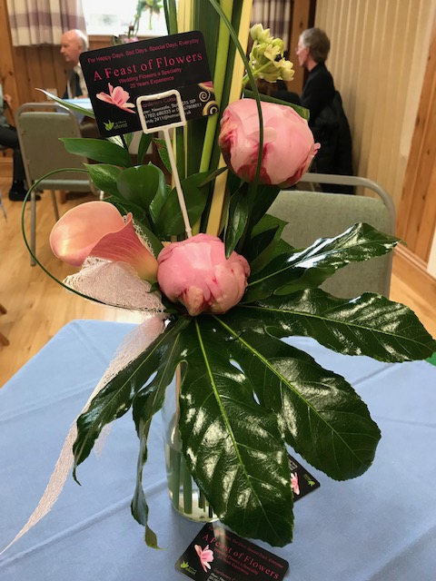

Lots of great chat and new friends made and hopefully some new ideas and support for events for the village. We will definitely be putting on another event nearer Christmas time – date TBA

**Speed through the village**

There have been a few comments about the speed of vehicles driving through our village, and there has been damage to an old stone wall, and near misses to our beautiful shire horses.

If you see this happening then please let the Parish Council members know – we need evidence to help with changes to signage.

Thank you

**The Maer Book -** In 2012, a group of local residents worked very hard to produce 'The Maer Book' - a history of Maer and its nearby villages, including many recollections and photographs. There are no new copies available to buy, but if any Maer residents want to borrow a copy, contact Wendy at the Old Laundry (01782 680613 or [wendy.kinson@tiscali.co.uk](mailto:wendy.kinson@tiscali.co.uk)) as she has a copy available for loan

**NEWS on our previous events**

**Womens Institute Celebration**

To commemorate their 100 years the Maer and District WI held a special Church service followed by a superb WI tea in the village hall. This was attended by many members and supporters of the WI. Lots of memorabilia was on display as well as an excellent variety of cakes to enjoy.

If you would like further information about the WI then please contact Pat Cawthorn

patricia.cawthorn@sky.com

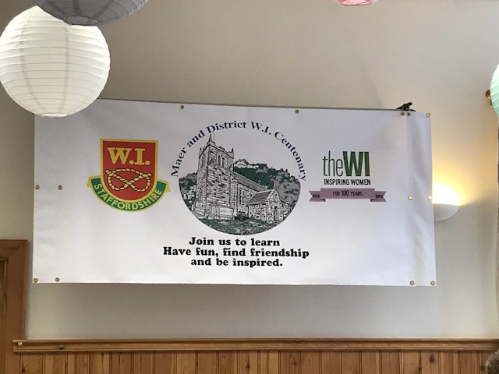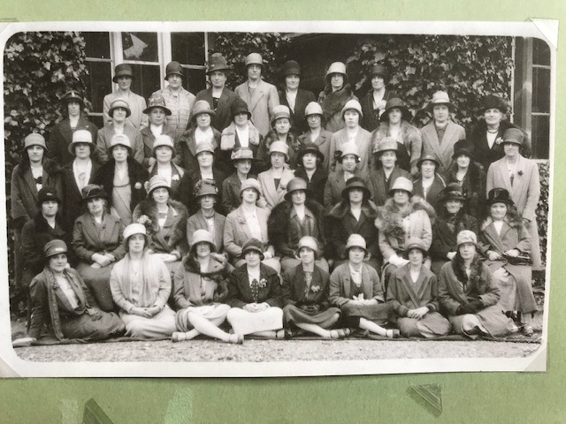

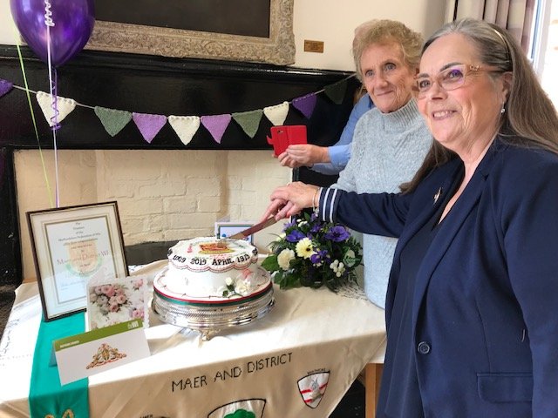 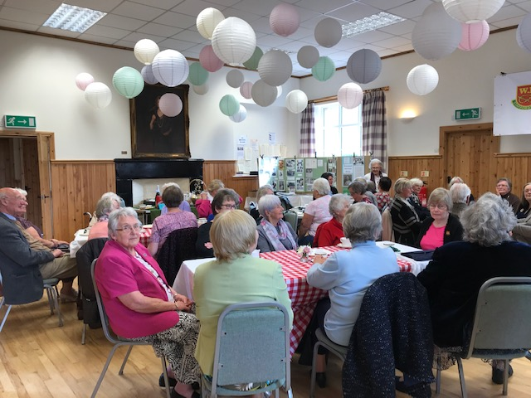

|  |  |
| --- | --- |
| future dates for your diary  14th June – Midsummer in Maer  27th Sept –The Mighty Quiz  16th Nov – The Autumn Fair | |
|  |  |
|  |  |
|  |  |
|  |  |
|  |  |



We would like to invite you to

**Midsummer in MAER**

An evening of music, nibbles and tipples

At

St Peter’s Church, Maer

Friday 14th June 2019

At 7.30pm

Live folk music from Paul Walker and Karen Pfeiffer



Please RSVP by 7th June (for catering) to

Nigel Clemas – [nclemas@hotmail.com](mailto:nclemas@hotmail.com)

Dorothy Bennison - 01630 655738

Village Activities

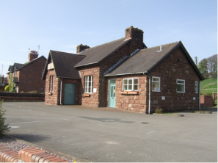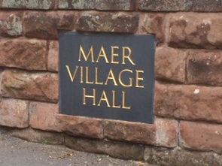

**Parish Council (Maer and Aston) -** www.maerastonparishcouncil.co.uk

The Parish Council meetings are open to everyone in the Parish.

The next meeting is on Thursday 20th June in Aston Village Hall at 7.30pm

Your local councillors are Linda Chesterton, Pat Stanier and Elena Sudlow (clerk)

Please contact them via the website to discuss any local issues or suggestions

**Garden Guild**

The next meeting will be held on Monday 17th June which is a visit to Karibou Gardens in Uttoxeter from 2pm

**WI**

The next meeting is at Maer Village Hall at 7.30 on **June 12th**

Chris Mayer  - “Kumihimo”   Japanese braiding  - A chance to learn a new skill

**YOGA**

Yoga classes on Thursday nights from 6-7pm (beginners) and 7.15-8.15pm (advanced)

Please contact Pip for more details: 07902660814 or [www.yogawithpip.com](http://www.yogawithpip.com).

Church services

1st Sunday of the month - 8 am Holy Communion

2nd Sunday -  9.30 am Family Service

3rd Sunday - no service at Maer (9.30 am at Chapel Chorlton)

4th Sunday - 9.30 am Family Service.

If there is a 5th Sunday, there is a joint service at one of the three churches (Maer, Chapel Chorlton or Whitmore).

The Church Magazine 'One Way' is published monthly and there are always copies in the Church

**Village website** www. maervillage.co.uk if you have items to add please contact Linda on maervillagehall@gmail.com